Assignment Mandatory

* Create a dummy lambda function with Python 3.9 runtime. After creation click on test and select Configure test event, from template option, select S3Put. It shows you the JSON event that is passed from S3 to Lambda service when a put event happens on S3.
* Review the JSON file and as you see, there are entries like bucket name and object key.
* The assignment is you write a Lambda function in Python that it prints the bucket name and object name when you upload an object in S3.
* In S3, learn how to create an event to call a lambda function.

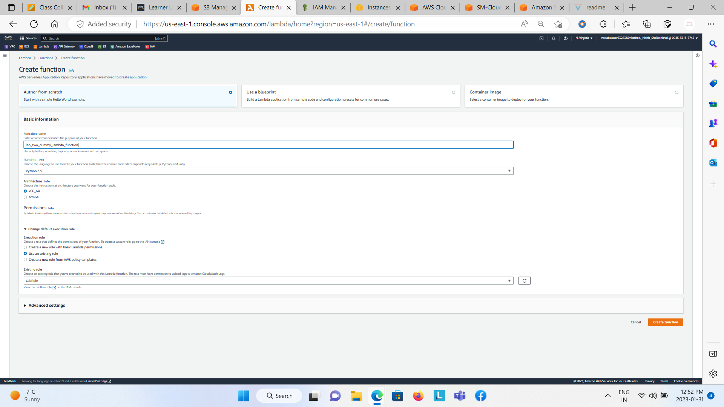

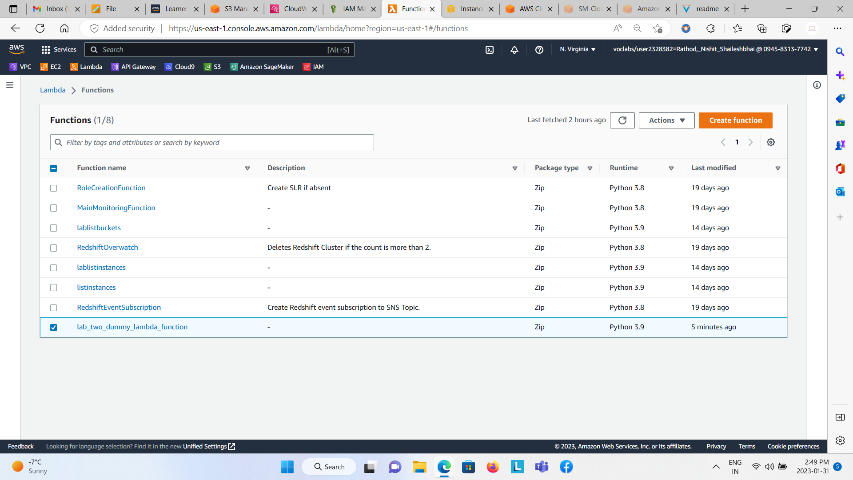

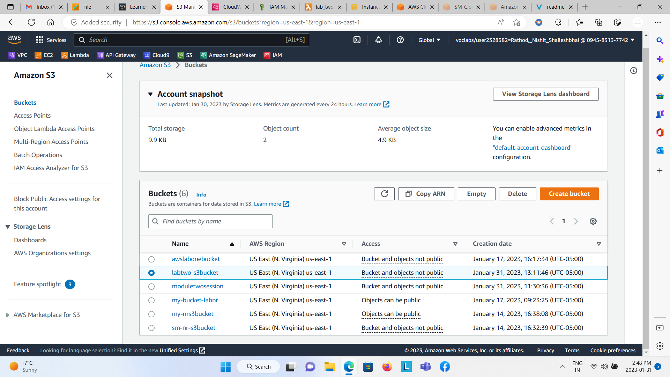

Go to the lambda function that was initially created and click on Test.

Create a new event under Test Event, Set the event name and Select S3 PUT from the template and save it.

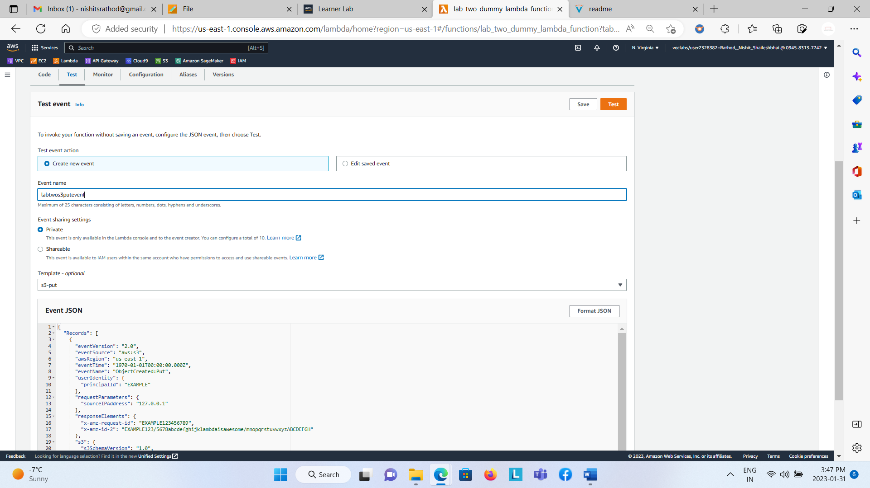

Add the S3 Trigger to the Lambda Function

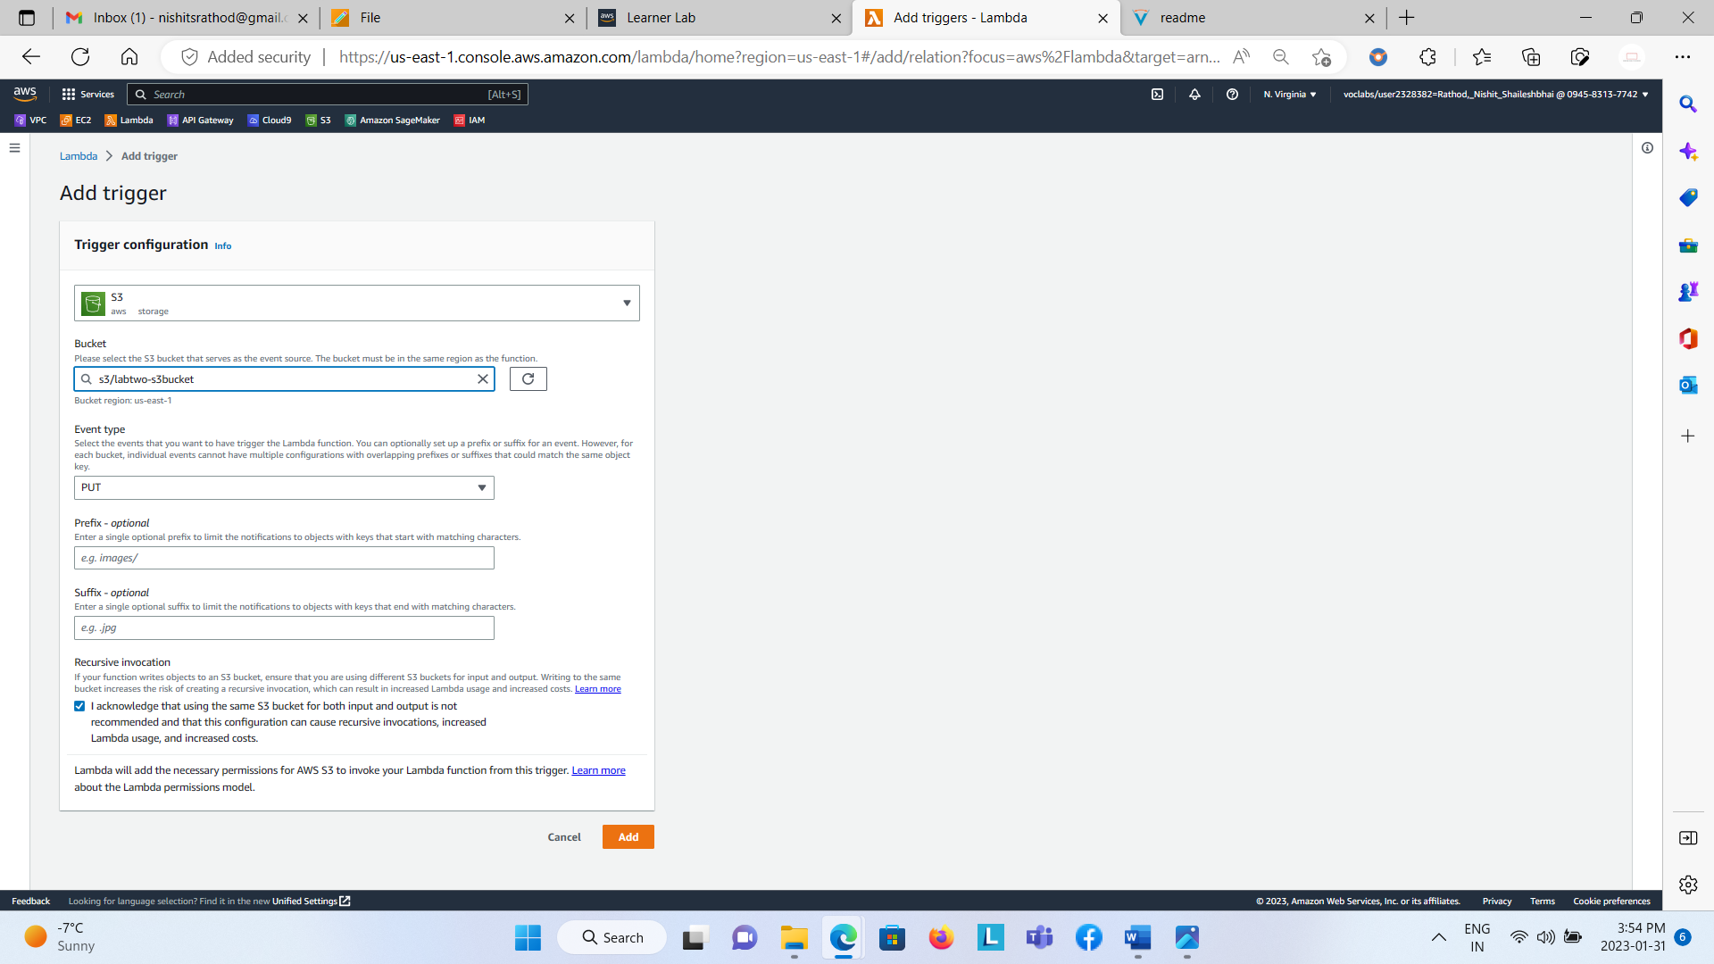

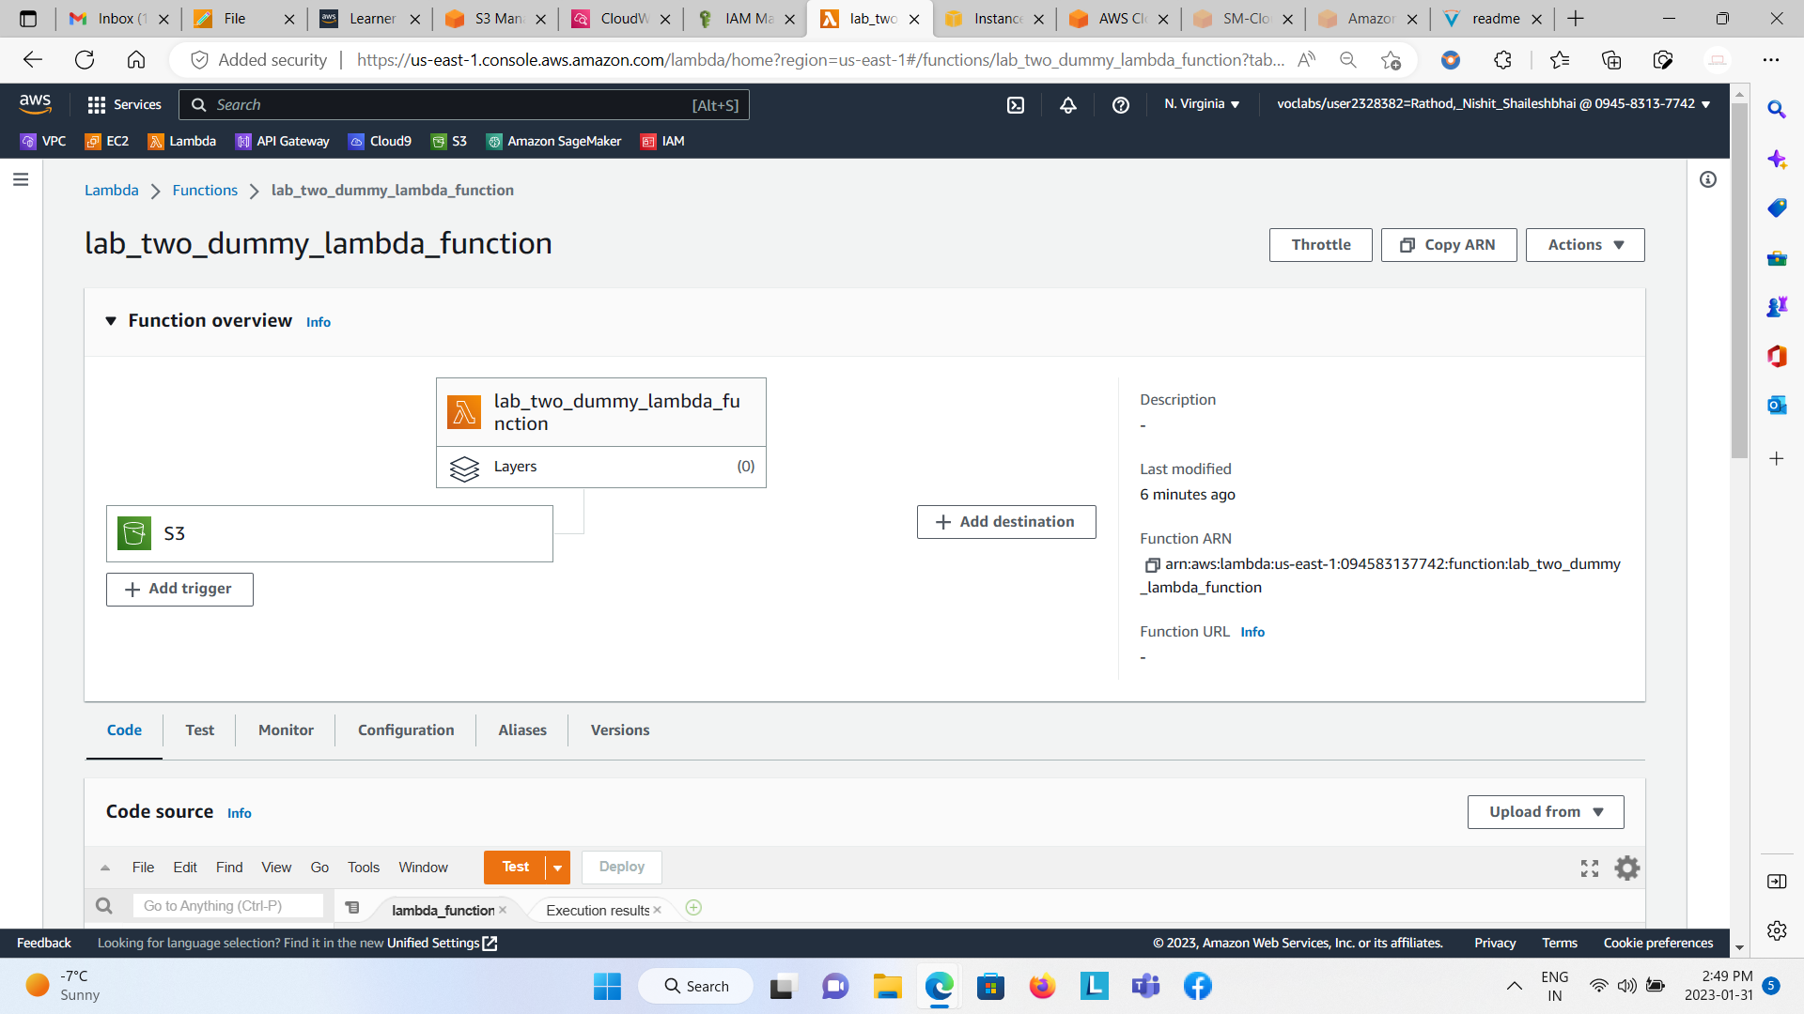

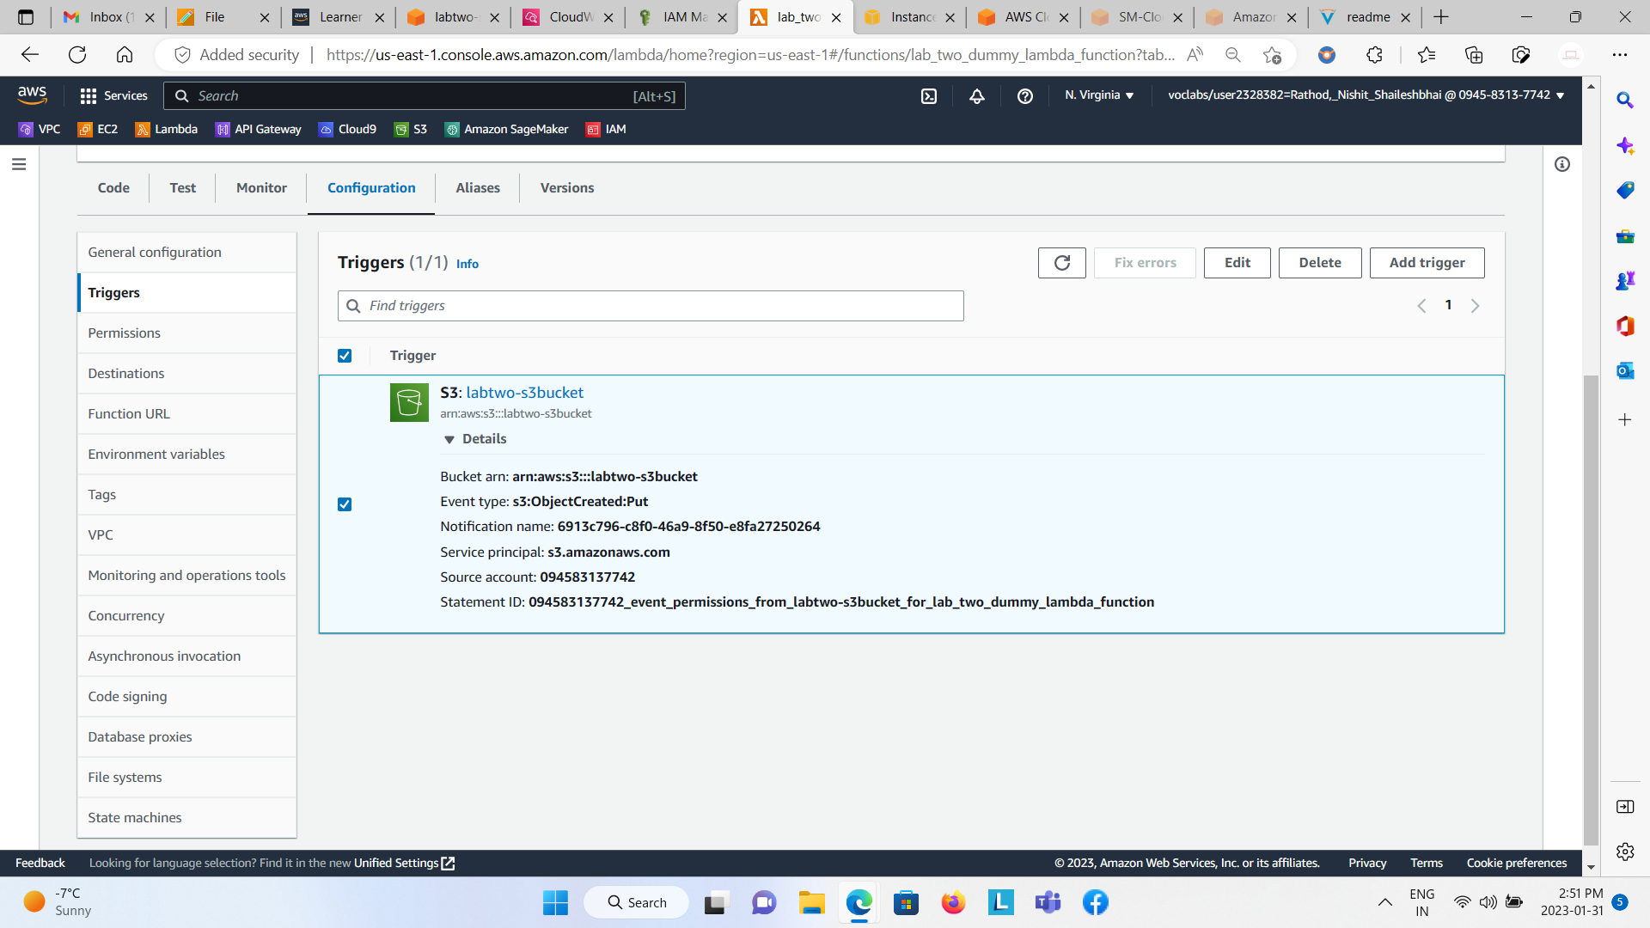

Or you can go into your S3 bucket, select properties tab and navigate towards the event notification and create it.

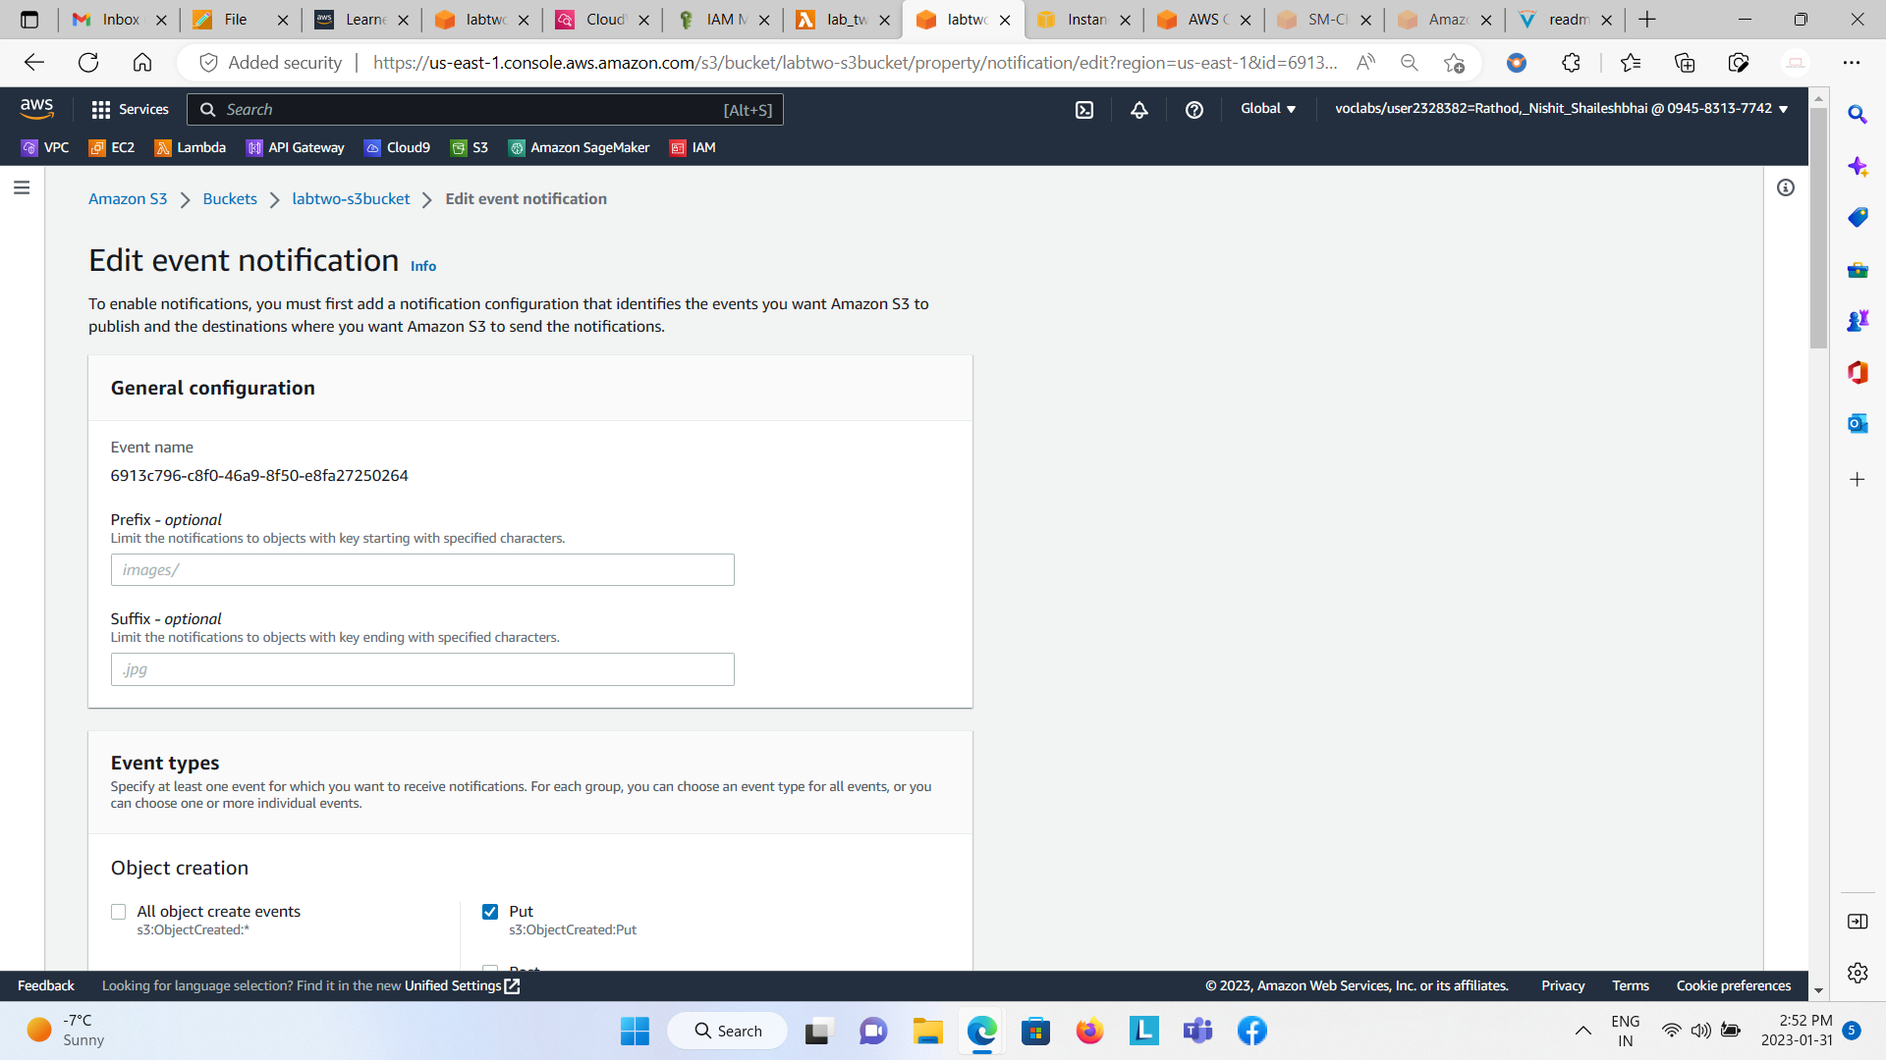  
  
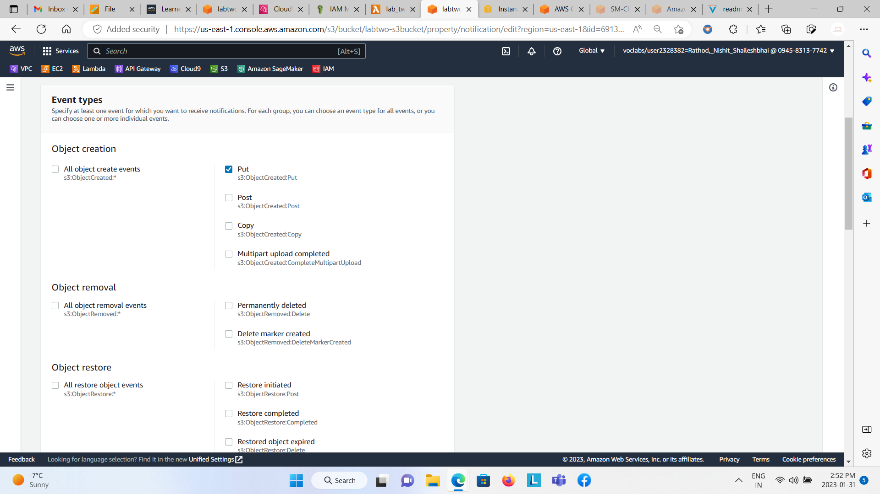  
  
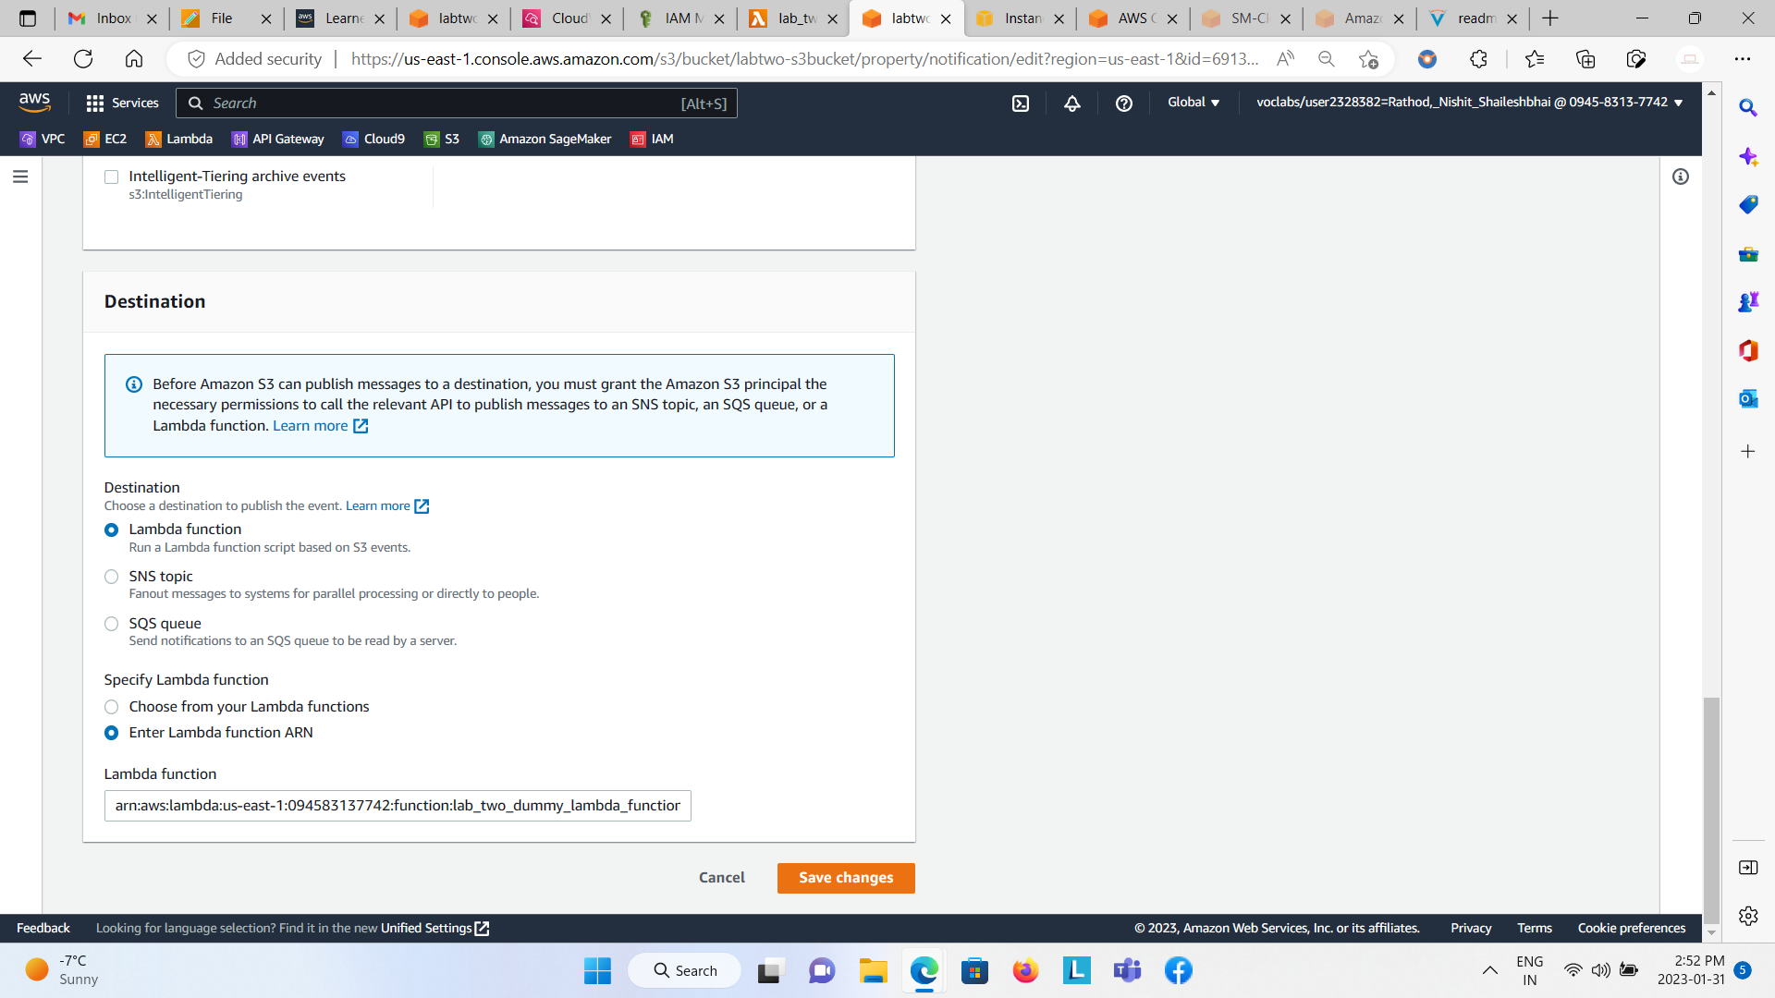

From Lambda Function, go to the Test Event, click on edit saved event. Choose the created event name and you will be able to see the JSON code. Edit the entries like S3 bucket name, arn and object key [Note: Once the object is been uploaded in that S3 bucket you can edit the entries].

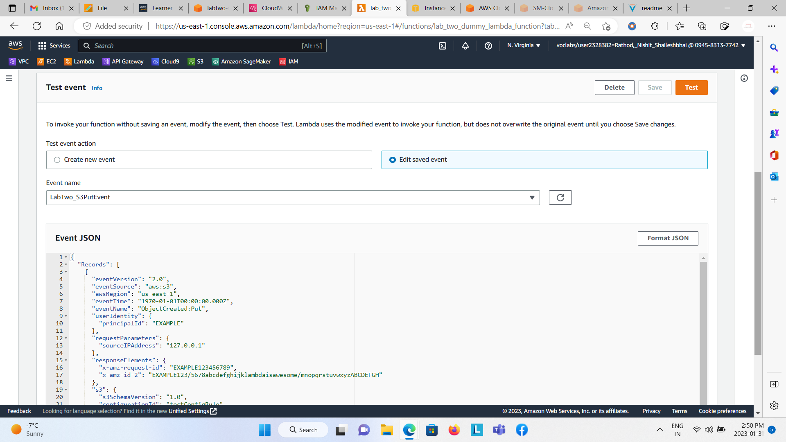  
  
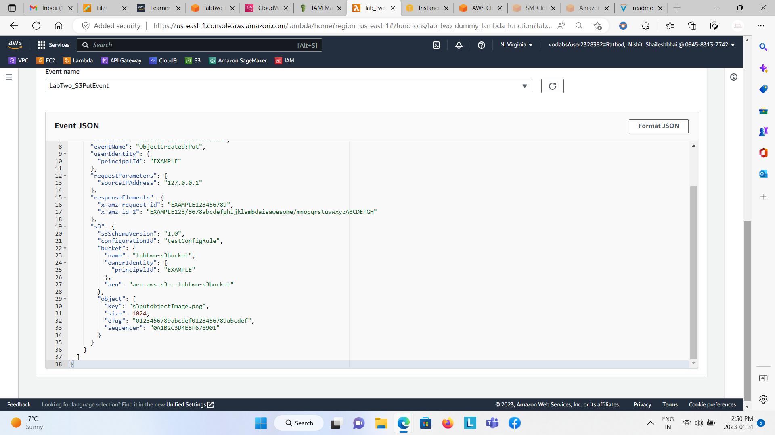

Before that, write the lambda function code as I have writtern below to get the Bucket Name and Object Key of that uploaded object in the S3 Bucket.   


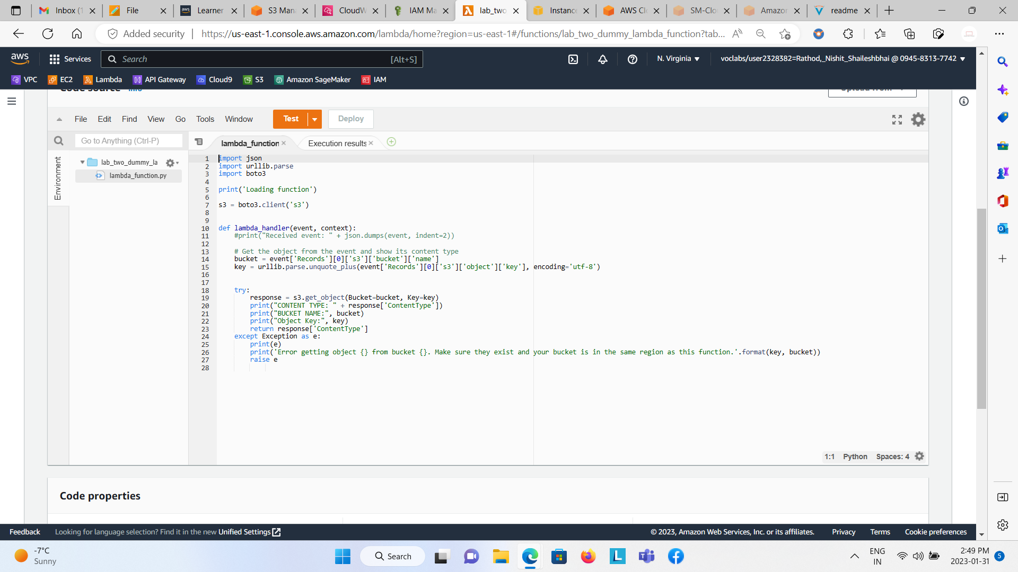

Before testing this code we have to upload the the file in S3 bucket which will act as our object.

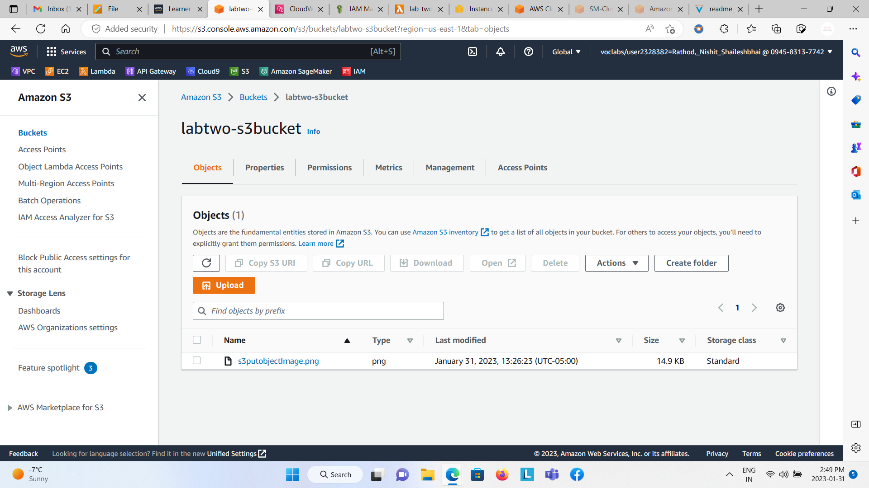

Now we have to execute the code from the lambda function which will output the Bucket Name and Object Key.

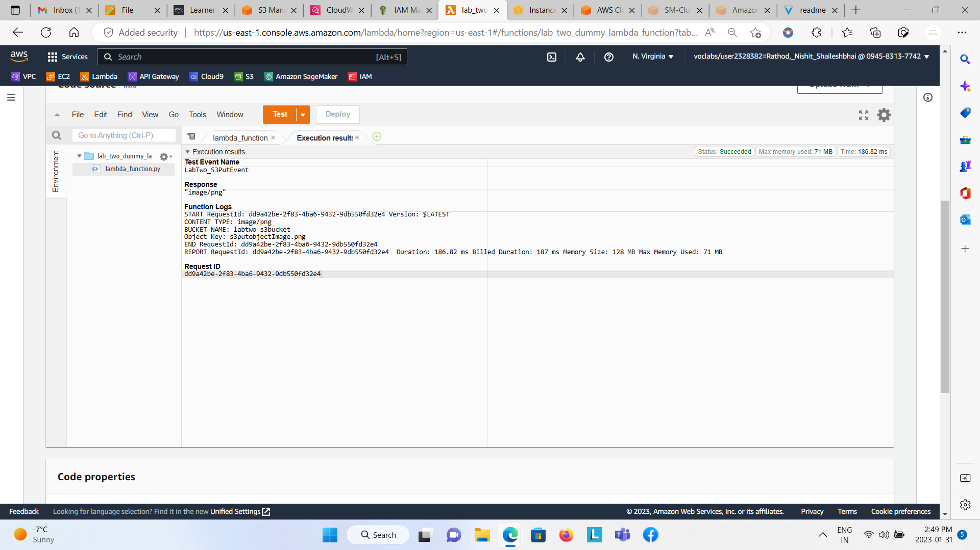

Just to rectify the things we were doing is correctly functioning or not we can navigate to the CloudWatch and see the log files.

